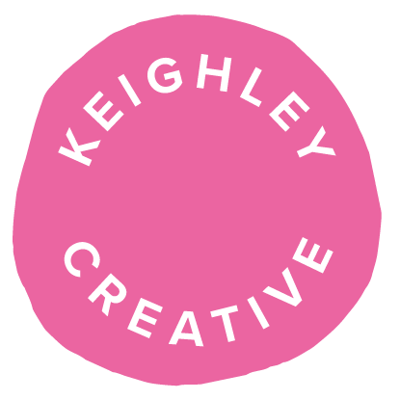

Arts & Heritage Officer
Keighley Creative Hub
This Arts & Heritage Officer will be based at Keighley Creative.
Keighley Creative is an arts charity determined to make things happen for Keighley. It is home to:
- Artist Studios - low-cost workspaces for people to grow their creative businesses.
- Stockroom Cinema - Keighley’s secret cinema and performance space, co-hosted by The Unit & LIFF.
- Arts for Brain Health Programme - free weekly sessions to get creative and take time for yourself.
- The Drawing Box Project - because everyone can draw, and we’ll give you the tools to do it!
- Keighley Creative Presents - large-scale events and community projects in Keighley for everyone.
The post holder will work alongside Keighley Creative and Keighley Neighbourhood Office (Neighbourhoods and Community Services Team, Bradford Council) to identify four specific residential sites of community interest across the Keighley Wards. Once these sites have been identified, street clusters and key residents across the sites will form the network for community engagement.
Working with these communities throughout this 2-year funded project, the post holder will support local residents to explore and respond to their personal and shared heritages, before embarking on the creation of a major artistic site-specific response that will go live during the City of Culture year, creating a lasting and positive legacy for these neighbourhoods.
The following are specific to the Arts & Heritage Officer who will be based at the Keighley Creative:
Reports to | Creative Lead, Keighley Creative
Office Base | Working from Keighley Creative, 3-7 Cooke Lane, Keighley, BD21 3PF  The post may require local and regional travel.
Desirable Languages | It would be desirable (but not essential) if the post holder could speak one of the following languages: a South Asian dialect / an Eastern European dialect.
Desirable knowledge | It would be desirable (but not essential) if the post holder has:  - Knowledge relevant to communities/groups in Keighley, local to Keighley Creative.  - Knowledge of working-class art forms and cultures.  - The understanding of specific art forms and cultures relevant to English, Pakistani, and Eastern European communities.
Desirable Experience | It would be desirable (but not essential) if the post holder has:  - Previous engagement with community work in Keighley.

