Ganges Theatre Plan

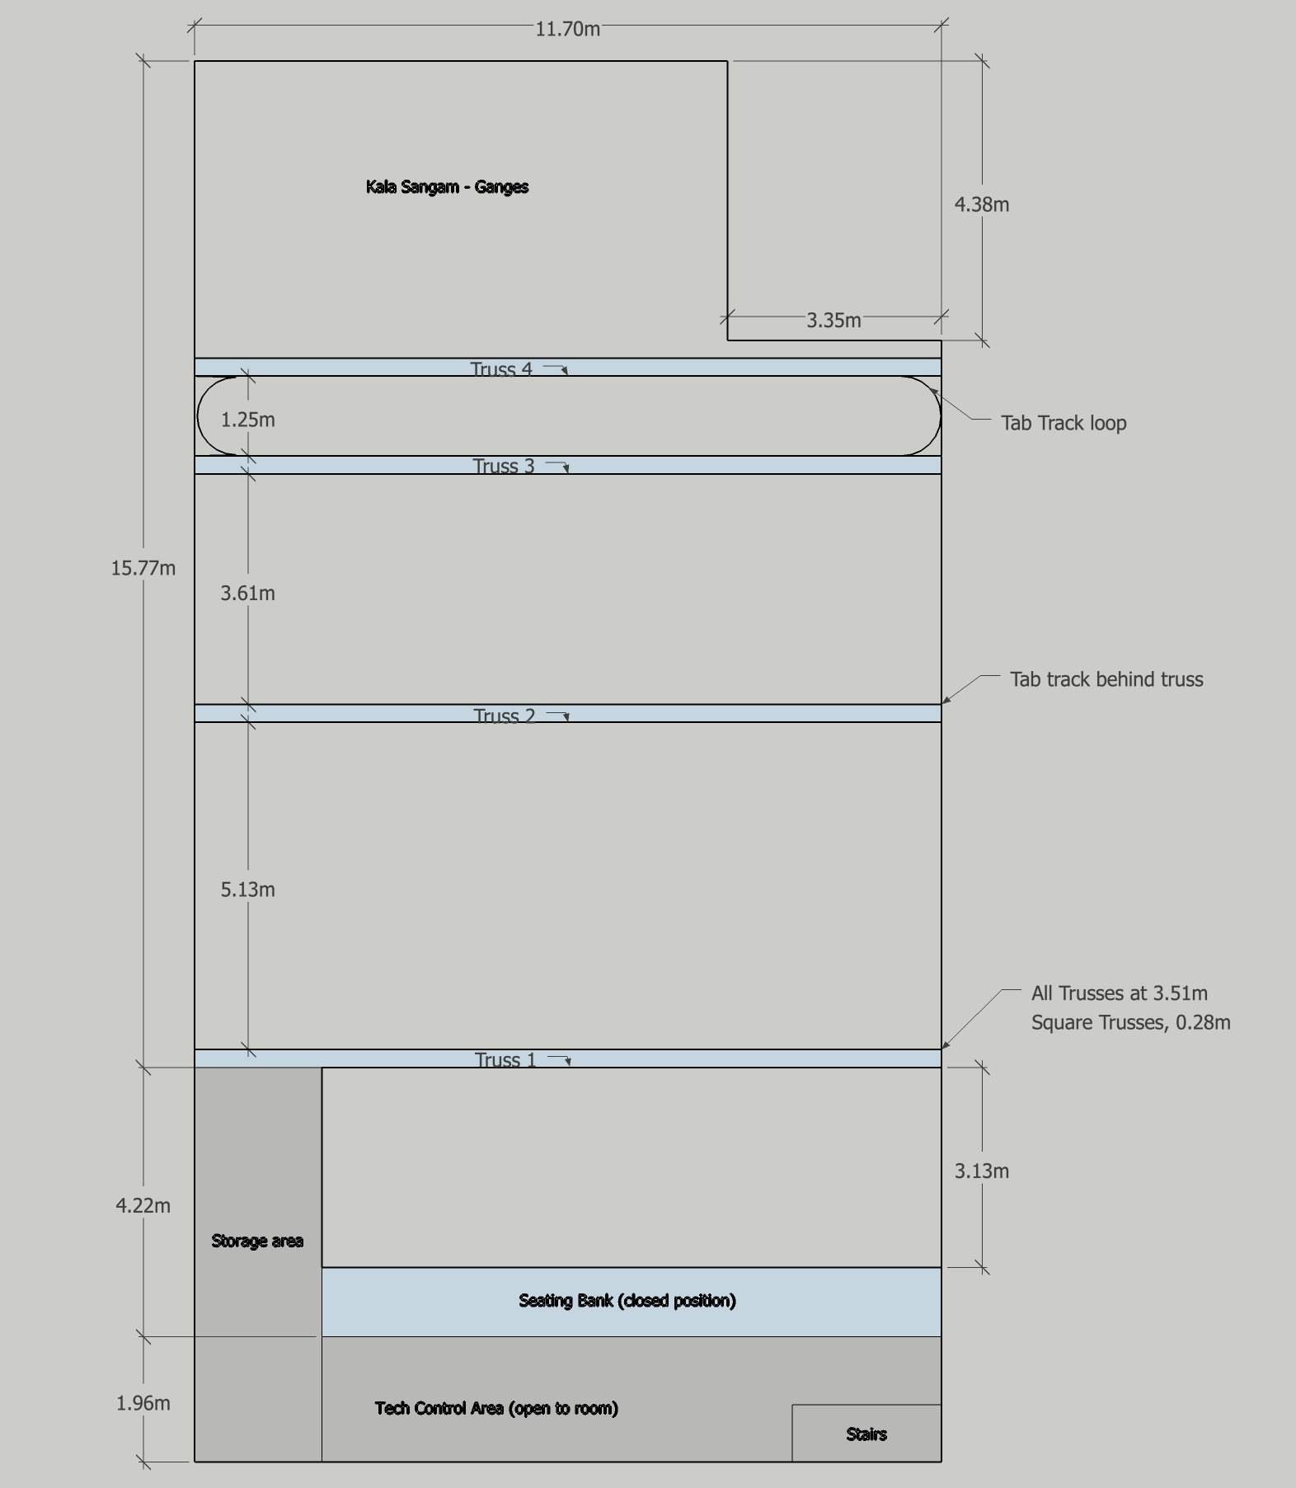

Lighting
- 6 x Nota F1200 Plus – 1000W (T19)
- 6 x Selecon Fresnel 500W (T18)
- 5 x CCT Minuette Fresnel 500W (T18/T25)
- 1 x Strand Quartet F – 500W (T18)
- 4 x ETC Source 4 Junior– HPE 575W
- 6 x Showtec Powerspot9 Q5
- 3 x Zero 88 Betapack 3 (socapex) – Six channels per LX bar
- 2 x ETC Light Bar Dimmers (4 Channels)
- 1 x Jester Zero 88 48 Channel Lighting Desk

Sound
- 6 x Shure SMS8 Wired Mics
- 4 x Shure SMS7 Wired Mics
- 1 x Sennheiser E835
- 2 x Shure PG1 85 Wireless Lavalier Mic
- 2 x Shure Wireless Vocal P658
- 1 x Allen & Heath Qu-16 Sound Desk
- 2 x DB FM12 Floor Monitors
- 2 x DB FOH Speakers (flown)
- 2 x DB Mon Speakers (flown)
- 2 x Bose portable rehearsal system
- 1 x Yamaha Mix EMX66M
- 2 x Wharfedale EVP S10 speakers
- 1 x HK Lucas SMART system
- Tascam CD200 Cd Player
- Yamaha Q2031 Graphic Equaliser 31 Band Stereo
- Altair EF200 Comms Station with four belt packs and headsets

