Trustee Pack

Thank you for your interest in becoming a trustee of Kala Sangam.

Based in Bradford, Kala Sangam is an intercultural Arts Centre which aims to reflect the diversity of contemporary Britain through the work we present, the artists we support and the communities we engage. Having celebrated our 25th Birthday in 2018, we are seeking to appoint additional trustees to strengthen our Board and help guide and support the staff to deliver a new, exciting, creative vision.

If you are interested in applying to become a Trustee we’d encourage you to first read the Charity Commission’s essential trustee guidance which can be found here. This guidance explains the key duties and responsibilities of all trustees of charities in England and Wales, and what trustees need to do to carry out these duties.

Trustees are expected to attend four Board meetings a year, represent Kala Sangam at external events and are encouraged to attend performances at the venue when possible.

We would welcome an application from anyone who has time to spare and an interest in supporting Kala Sangam. On pages 5 to 8 you will find some descriptions of specific roles we have identified for Board members, if you feel you have skills or experience that would make you suitable for one of these roles then please do let us know in your application. As an equal opportunities employer we would welcome applications from all suitably qualified persons regardless of their race, sex, disability, religion/belief, sexual orientation, or age.

As well as the skills you will bring we expect all trustees of Kala Sangam to have an understanding of, support for and commitment to Kala Sangam’s current artistic strategy. You will find more information on this on pages 3 and 4. We also expect all trustees to have a strong commitment to diversity and equality.

There has never been a better time to join us, as we look to build on our outstanding reputation for delivering South Asian arts, and offer an even more diverse programme which will engage with communities and groups across Bradford and beyond. If you would like to be part of this journey I hope that you will consider applying to be a trustee.

I look forward to hearing from you

Yours sincerely

Caroline Harrison
Chair, Kala Sangam

Kala Sangam’s Artistic Strategy 2018 - 22

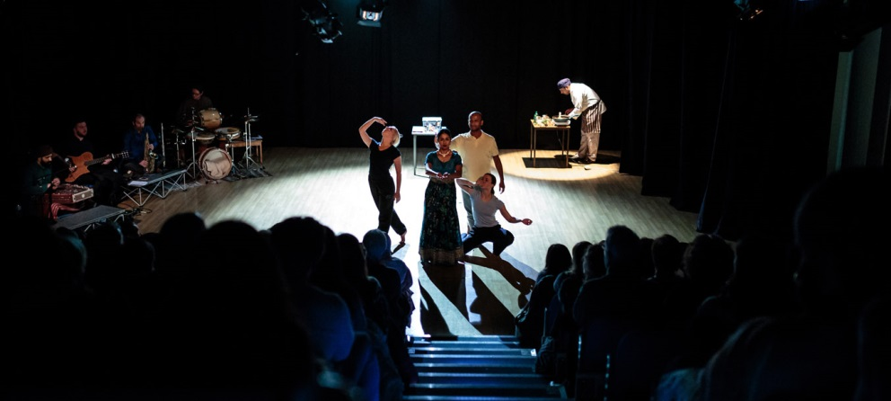
Balbir Singh Dance Company performing at Kala Sangam, Dec 2017

With the retirement of its founder Artistic Director (early 2017), Kala Sangam found itself at a pivotal point in its history. The company has put in place a new artistic strategy which has seen Kala Sangam move from being primarily South Asian-focused to becoming a truly intercultural arts hub.
We aim to better support artists and engage communities that reflect wider diversity in contemporary Britain – and therefore the company’s home city of Bradford. This new strategic direction recognises that widening engagement, to encompass more of Bradford’s communities, is important for the company’s future resilience – both financially (through increasing audience numbers and use of the building) and by ensuring that KS remains relevant.
Kala Sangam now has three primary public facing strands (below). All artistic, education or outreach activity delivered by KS during 2018-22 is expected to align with at least one of these strands – be that work presented in the Ganges Theatre, the artists we support (and the work they create), our schools offer, or any of the other ways in which we deliver our work.
Primary Strand #1: ‘This is Bradford’
We present work created by Bradford-based artists/organisations, and present work and deliver activity that addresses societal issues for the city. This strand of programming positions Kala Sangam at the heart of Bradford’s arts sector – our aim is for KS to become thought of as the hub for artistic activity in the city. This strand also ties in closely with BMDC’s place-making agenda.
Primary Strand #2: ‘South Asia Now’
We present and deliver South Asian music and dance activity and performances, with a priority placed on work which explores South Asian culture and heritage from a British Asian perspective and/or develops the artform.
The main focus of this strand is to support the development of British artists of South Asian descent. This strand aims to place KS at the forefront of the discussion about what it means to be someone of South Asian heritage in Britain today. This strand may also include an element of programming high-quality performances by international artists/companies, where there is a measurable benefit to Bradford audiences.
Primary Strand #3: ‘British Diversity’
We present work and deliver activity which explores and reflects the cultural heritage and diversity of modern Britain. This includes work reflective of all protected characteristics, including age, disability, race, gender, sexuality and those people in society from lower socio-economic groups.
This strand is designed to directly support KS in playing a leadership role in presenting work, and learning, related to the Creative Case for Diversity.

The Creative Case for Diversity is now at the heart of everything we do. Kala Sangam aims to not just deliver, but lead this conversation. By broadening the organisation’s reach we aim to reflect and engage all communities of Bradford, presenting and supporting the creation of work that is relevant, impactful and reflective of modern Britishness. We are developing more diverse artists, and offering more ways for the communities of Bradford to experience creative work. We will also be a strong advocate for the Creative Case, sharing our knowledge and leading conversations across the arts sector, regionally and nationally.

The three Primary strands underpin a fourth strand – a commitment to developing new work:
Underpinning Strand #4: ‘Born at Kala Sangam’
We support artists and companies to create new work aligned with at least one of our three Primary Strands.

The scale of delivery for this strand is dependent on additional funding secured over the course of the period. As a minimum, we will: deliver an annual Artists Takeover (minimum three artists paid and supported to develop new work); offer ongoing artistic, funding and organisational support to Bradford-based artists and artists working in South Asian artforms; provide an increased amount of space as support-in-kind to artists developing work.

2018-22 will see a significant increase in the number of artists supported by KS (already reflected by engagement figures since mid-2017) with KS looking to establish itself as a key resource, regionally and nationally, in supporting the development of artists from diverse backgrounds.

Kala Sangam Board roles

We would love to hear from anyone that believes they could contribute positively as a Kala Sangam Board member. If you have the spare time and commitment needed, please do get in touch.

Following a skill audit we have also identified a number of ‘model Board’ roles that we would like to fill. Over the next few pages you will find a description of these roles, with a list of the desirable attributes we are looking for. Some of these roles already have postholders in place, however if you feel you have the skills to fill any of these we would still like to hear from you.

Please note on your application if you feel you have the skills to meet one or more of these roles.

Chair

The Chair leads the Board of Trustees, chairing Board meetings and acting as line manager to the organisation’s Creative Director. As a figurehead for the organisation, the Chair is expected to regularly represent (and promote) the organisation at external meetings and events.

Desirable attributes:

- Significant experience of leading and chairing meetings.
- Line management experience.
- Excellent people and communication skills.
- Experience of being a trustee in the third sector.
- Good understanding of the political, cultural and commercial context in Bradford, the region and nationally.

Treasurer

The Treasurer oversees the financial matters of the charity, ensuring budgets are accurate and the financial health of the organisation is accurately represented at Board meetings.

Desirable attributes:

- A formal accounting qualification.
- Experience of authoring and maintaining budgets over £500K.
- Clear understanding of financial regulations, particularly concerning the charity sector.

Marketing

This Trustee monitors and supports Kala Sangam’s marketing activity, offering advice and guidance to the Marketing Officer and Marketing Assistant where requested. The Trustee oversees the Marketing Officer’s annual update to the company’s Marketing & Audience Development Plan; ensuring SMART targets are set in line with funders’ expectations.

Desirable attributes:

- Experience of authoring and delivering marketing engagement projects
- Experience of authoring and delivering PR campaigns

HR

This Trustee supports the organisation’s Senior Management Team to ensure all policies and procedures remain best practice and regularly reviewed.

Desirable attributes:

- Experience of overseeing HR within a small to medium sized organisation.
- Clear understanding of current legislation (and best practice) regarding recruiting and hiring of new employees, employee benefits and disciplinary procedures.

Legal

Using their knowledge and contacts, this Trustee advises Kala Sangam’s Board and Senior Management Team on legal matters, signposting to other sources where external expertise is required.

Desirable attributes:

- Should hold an appropriate legally-defined qualification (e.g. a practising certificate).

Schools

This trustee oversees Kala Sangam’s delivery in schools, offering support and guidance when requested by the Education & Outreach Officer. With the Education & Outreach Officer, the Trustee will help to set annual SMART targets for this delivery in line with funders’ requirements.

Desirable attributes:

- Direct experience of working within, or supporting, schools within the last 5 years – if ideally in the Bradford district.
- A strong understanding of Artsmark.
- A clear understanding of the current Primary and/or Secondary Curriculum - in particular PSHE.

Outreach / Projects

This trustee provides support and guidance (when requested) to Kala Sangam’s Education & Outreach Officer as they develop and evaluate the Company’s community engagement and outreach projects. With the Education & Outreach Officer, the Trustee will help to set annual SMART targets for this delivery in line with funders’ requirements.

Desirable attributes:

- Experience of creating, budgeting and delivering community focused projects.
- Experience of authoring and managing successful funding bids to deliver outreach activity.
- A strong understanding of Arts Award.

Artistic – 2 Trustees

These two trustees support the Creative Director to ensure that performances and artist support at Kala Sangam is of best practice and high quality – with a particular focus on the dance, music and the South Asian arts sector. These trustees are expected to attend performances regularly, reporting to the Board on their experiences.

To support the company’s strategic artistic direction, these trustees should have:

- knowledge of the South Asian arts sector and its current trends and developments (nationally and regionally)
and/or
- current or recent experience as a practicing producer, musician, composer, dancer or choreographer.

Desirable attributes:

- Knowledge of national trends and developments with their chosen artform.
- Previous experience of evaluating the quality of performance (e.g. AQA assessor).

Fundraising

This Trustee offers guidance and support to the Senior Management Team as they look to prioritise best use of the company’s resources to ensure the maximum possible return from fundraising efforts. This may include feeding in to Trust & Foundation Applications (authored by the SMT), identifying possible new streams of income and ensuring Kala Sangam’s approach remains best practice.

Desirable attributes:

- Previous experience of developing successful fundraising strategies within a charity environment.
- A clear understanding of current Charity and Fundraising legislation and opportunities.

Bradford – Business

This Trustee has good knowledge of, and is well networked within, Bradford’s business community. Working with the Senior Management Team, this Trustee will help to raise the profile of Kala Sangam within the region’s businesses, promoting our values and identifying potential sponsors.

Desirable attributes:

- Strong personal networks within the regional business community
- A strong understanding of current Charity and Fundraising legislation and opportunities.

Bradford – Community

This Trustee has either a wide knowledge of the communities which make up Bradford’s population or a particular connection with one of the city’s communities. Of particular interest would be a link to one of Kala Sangam’s target communities for audience engagement - White British, Pakistani heritage, Eastern European heritage. This trustee supports the Marketing Officer as they look to develop effective ways to engage these communities.

Desirable attributes:

- Strong connection with and understanding of at least one of Bradford’s communities
- Multilingual
- An understanding of the challenges and issues faced by Bradford’s communities

How to apply

If you would like a confidential and informal discussion about any roles before applying, please contact Acting Creative Director, Alex Croft, (alex@kalasangam.org) who will be happy to answer any questions you may have.

To apply, please write to us, enclosing your CV to:
Kala Sangam, 1 Forster Square, Bradford, West Yorkshire, BD1 4TY.

Alternatively, you could email us at alex@kalasangam.org.

Letters should be marked for the attention of the Chair of Kala Sangam.

