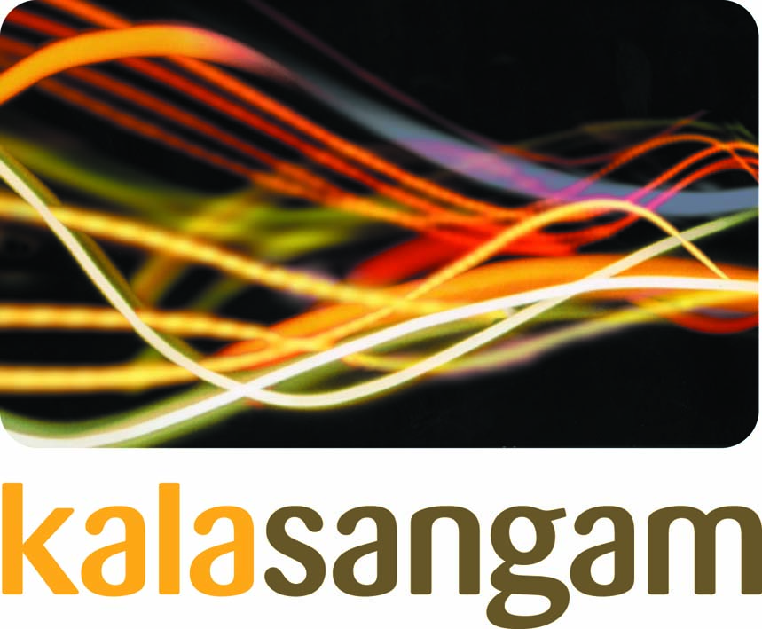
Marketing/Admin Officer (Maternity cover)
£18k pro rata PA (based upon 37 ½ hrs. full time)
Fixed-term contract, 22.5 hours per week

Kala Sangam is seeking a proactive individual to join their busy team for a period of maternity cover. You will have a strong track record in implementing and delivering both marketing and PR campaigns, good people skills, and proven experience of working on your own initiative to successfully meet deadlines.
Kala Sangam is an intercultural arts hub which aims to reflect the diversity of contemporary Britain through the work we present, the artists we support and the communities we engage. Under new artistic leadership this is an exciting time to join the organisation as it looks to expand its reach into communities across Bradford and beyond.
Specialising in South Asian arts and culture, most of our work takes place in our Arts Centre in the heart of Bradford’s Little Germany cultural quarter with our outreach activities extending nationally and internationally.
In Sanskrit, ‘Kala’ means arts and ‘Sangam’ means a meeting point. Kala Sangam aims to bring people and communities together to create and experience high-quality diverse art, to increase understanding and awareness of different cultures, and to provide talent development pathways for young people and emerging artists into a career in the arts.
The job description and application form can be downloaded from the Kala Sangam website
http://www.kalasangam.org/work-with-us/job-vacancies/

Closing date for applications: 12noon on Wednesday 09 August 2017
Interviews: Kala Sangam on Thursday 17 August 2017
Start date: Monday 04 September 2017
Kala Sangam is committed to safeguarding and this post is subject to successful references.
Kala Sangam, St Peters House, 1 Forster Square, Bradford, BD1 4TY
